8.2 Reaction pathway diagram
Name: ____________________ Class: ____________________ Due date: 10.20
1. The energy level diagram for a reaction is shown.
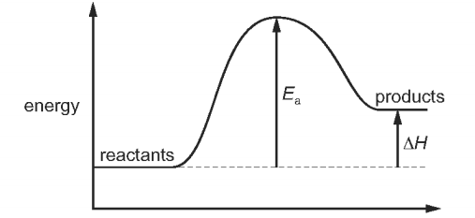
Which statement is not correct for this energy level diagram? （ ）
A It could be the energy level diagram for the reaction when petrol is burnt.
B Less energy is released in bond forming than is needed for bond breaking.
C The activation energy, Ea, has a positive value.
D The energy change, ΔH, for the reaction is positive.

2. The energy level diagram for a reaction is shown.
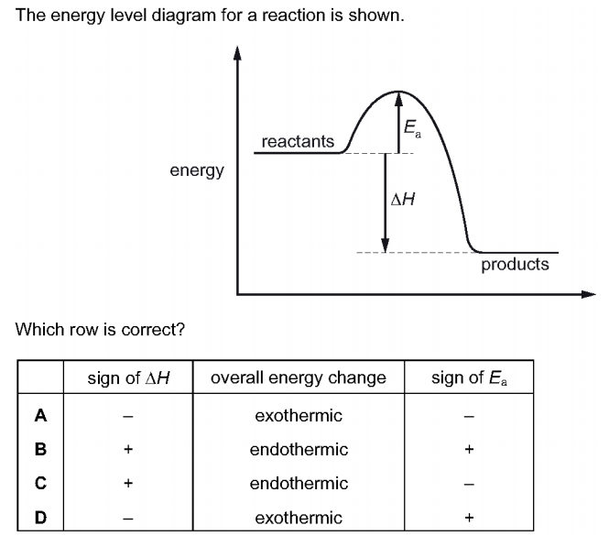
Which row is correct? （ ）
3. The energy level diagram for a reaction is shown.
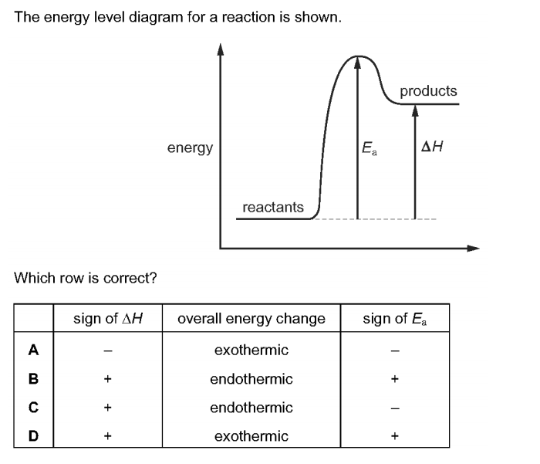
Which row is correct? （ ）
4. Which diagram is a correctly labelled energy level diagram for an endothermic reaction? （ ）
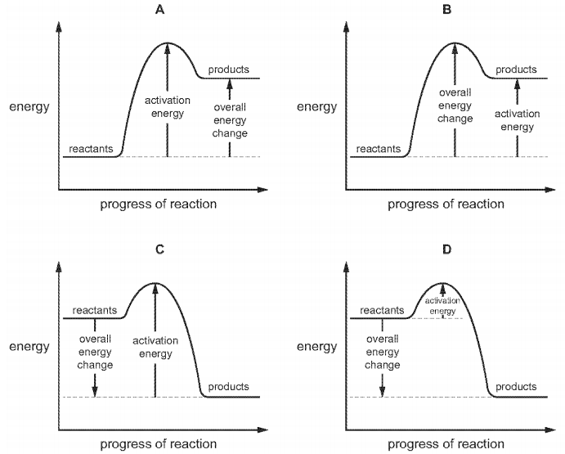

5. An energy level diagram for a reaction is shown.
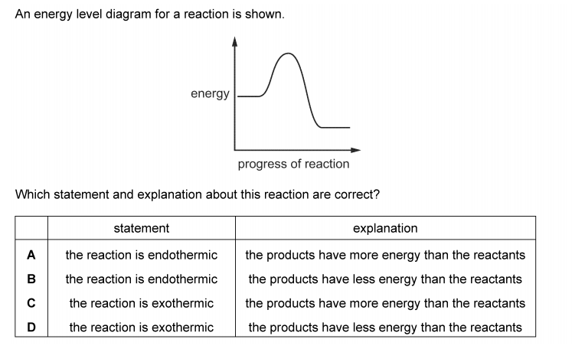
Which statement and explanation about this reaction are correct? （ ）

6. Explain why combustion reaction is exdothermic overall, in terms of bond making and bond breaking.

7. The reaction in following is exothermic.
4NO₂ + 2H₂O + O₂ → 4HNO₃
Complete the energy level diagram for this reaction. Include an arrow that clearly shows the energy change during the reaction.
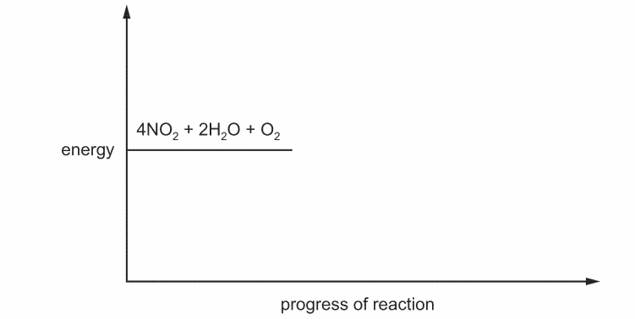

8. The chemical equation for the complete combustion of ethanol, C₂H₅OH, is shown.
C₂H₅OH + 3O₂ → 2CO₂ + 3H₂O
The energy released when one mole of ethanol undergoes complete combustion is 1280 kJ.Part of the energy level diagram for this reaction is shown.
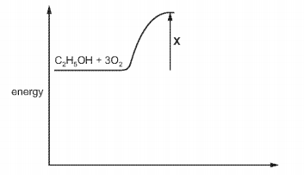
(a) Complete the energy level diagram to show
• the products of the reaction,
• the overall energy change of the reaction.
(b) What does X represent?

9. For a reaction to take place, two steps must occur. What are they?
(Your answer should include the word bonds!)

11. Define, and give the symbol for:
a activation energy
b enthalpy change in a reaction
Why is activation energy needed, in a reaction?

12. In a certain reaction, the bonds between atoms within the reactant molecules are weak. Is the activation energy for this reaction likely to be high, or low?

13. Copy this reaction pathway diagram:
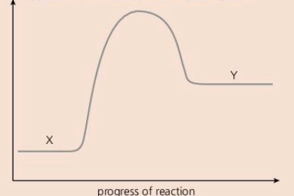
a On your diagram:
i label the vertical axis
ii give the correct terms for X and Y.
b Is the reaction exothermic, or endothermic?
c Will the temperature of the reaction mixture rise, or fall, during the reaction?

